**Lab – Building a Virtual Install of Server Core from a Full GUI Install**

**For this lab, students first need to create a second full install with GUI of Server 2012 r2 standard edition. This lab demonstrates how to covert a full install with GUI to either minimal install with Server Manager or an install of Server 2012 r2 Core.**

**Overview**

In this lab, students will switch between full GUI and Server core in windows 2012 using Powershell. Most of what you learn in this lab will be testable on the 70-410 exam.

The Server Core installation installs the operating system in non-GUI with minimal footprint and helps to secure the server running Hyper-V role. The benefits of using core server are:

* Reduced attack surface
* Reduced maintenance
* Consume fewer hardware resources
* Increased stability due to fewer running applications

The Full Server Installation installs the operating system with full GUI allowing us to perform all administration and Hyper-V related operations locally on the server.

**Begin Lab –**

We begin the lab by converting our full installation with GUI to Server Core with GUI Management and then to Server Core.

The best way to complete this lab is to copy and paste the commands into Powershell.

**Change from full Server to minimal interface mode.**

From your Server 2012 r2 desktop, launch Powershell.

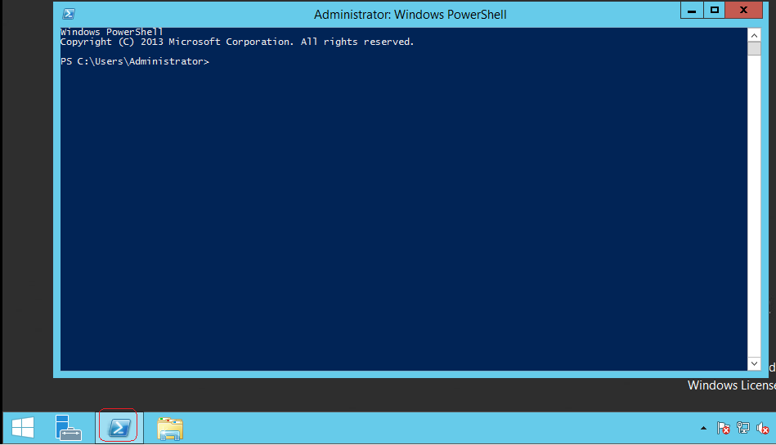

Import-Module ServerManager

[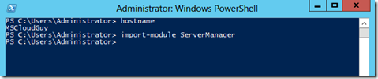](http://blogs.technet.com/cfs-file.ashx/__key/communityserver-blogs-components-weblogfiles/00-00-00-84-40-metablogapi/7701.image_5F00_1CD44DD2.png)

Uninstall-WindowsFeature Server-Gui-Shell -Restart

[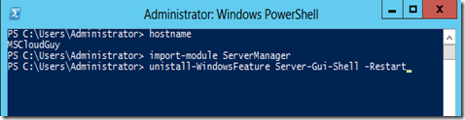](http://blogs.technet.com/cfs-file.ashx/__key/communityserver-blogs-components-weblogfiles/00-00-00-84-40-metablogapi/7457.image_5F00_0BA0702F.png)

[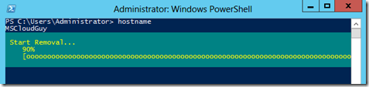](http://blogs.technet.com/cfs-file.ashx/__key/communityserver-blogs-components-weblogfiles/00-00-00-84-40-metablogapi/7838.image_5F00_1CC42805.png)

Reboot the Server

[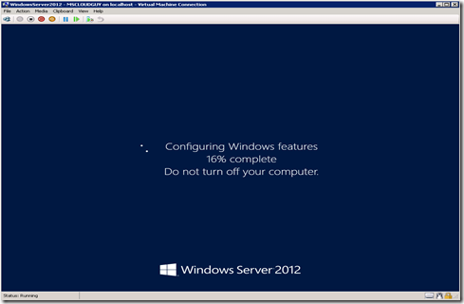](http://blogs.technet.com/cfs-file.ashx/__key/communityserver-blogs-components-weblogfiles/00-00-00-84-40-metablogapi/0167.image_5F00_2081CCD5.png)

**Server Core with GUI Management (Minimal Server Interface**

Launch the PowerShell Window. Type Start[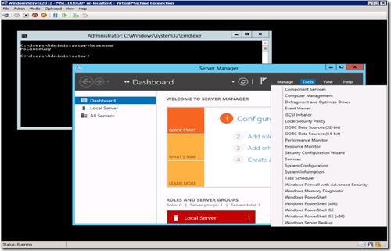](http://blogs.technet.com/cfs-file.ashx/__key/communityserver-blogs-components-weblogfiles/00-00-00-84-40-metablogapi/3683.image_5F00_06EA19DB.png) Powershell at the command prompt and hit Enter.

[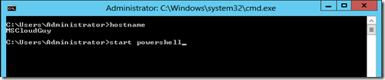](http://blogs.technet.com/cfs-file.ashx/__key/communityserver-blogs-components-weblogfiles/00-00-00-84-40-metablogapi/6813.image_5F00_4E2F4A00.png)

[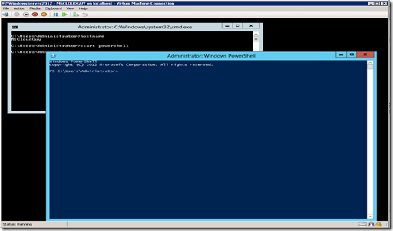](http://blogs.technet.com/cfs-file.ashx/__key/communityserver-blogs-components-weblogfiles/00-00-00-84-40-metablogapi/0601.image_5F00_4B39E54D.png)

Uninstall-Windowsfeature Server-Gui-Mgmt-Infra -Restart

[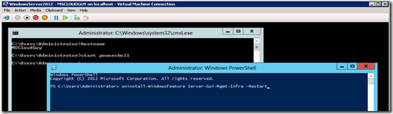](http://blogs.technet.com/cfs-file.ashx/__key/communityserver-blogs-components-weblogfiles/00-00-00-84-40-metablogapi/4807.image_5F00_53F9C7CC.png)

Press Enter and uninstall begin.

[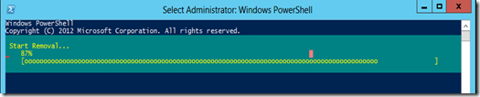](http://blogs.technet.com/cfs-file.ashx/__key/communityserver-blogs-components-weblogfiles/00-00-00-84-40-metablogapi/7674.image_5F00_31FE3F7B.png)

Reboot the Server.

[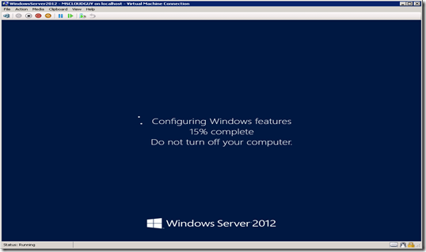](http://blogs.technet.com/cfs-file.ashx/__key/communityserver-blogs-components-weblogfiles/00-00-00-84-40-metablogapi/5428.image_5F00_3C6EEDCE.png)

To get back our full GUI install, we can use the command prompt one of two ways to do so though both use the same tool – **DISM** (***Deployment Image Service Manager***).  When you are doing it for a single (local) server, the command is:

**Dism /online /enable-feature /featurename:ServerCore-FullServer /featurename:Server-Gui-Shell /featurename:Server-Gui-Mgmt**

While the DISM tool works fine, it is the Powershell that allows you to manage more than one server remotely   The script in PowerShell would be nearly as simple:

**Import-Module Dism   
Enable-WindowsOptionalFeature –online -Featurename ServerCore-FullServer,Server-Gui-Shell,Server-Gui-Mgmt**

[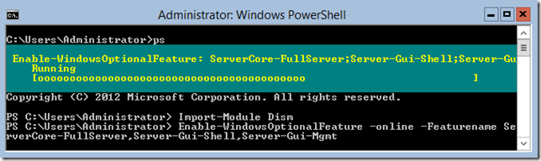](http://blogs.technet.com/cfs-file.ashx/__key/communityserver-blogs-components-weblogfiles/00-00-00-48-12-metablogapi/1385.image_5F00_026610C4.png)

To remove the Gui features or Convert Server full GUI back to Server Core using DISM, use the following command.

Dism /online /Disable-feature /featurename:ServerCore-FullServer /featurename:Server-Gui-Shell /featurename:Server-Gui-Mgmt

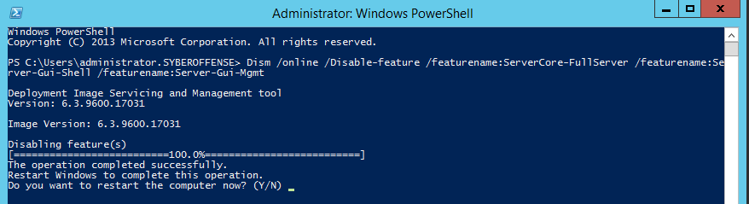

In this lab, we looked at the different ways we can change from Server core to Full GUI and the Server core with the minimal graphic user interface. But there is still another way to get the MiniShell with Server Core.

MinShell (Minimum Shell) offers the administrator the best of both worlds.  You have the GUI management tools (Server Manager) but no actual GUI, which means that you are still saving the resources and providing a smaller attack surface but with full manageability.

[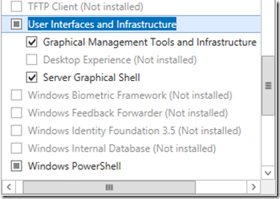](http://blogs.technet.com/cfs-file.ashx/__key/communityserver-blogs-components-weblogfiles/00-00-00-48-12-metablogapi/5504.image_5F00_1612FA58.png)

Under **User Interfaces and Infrastructure** there are three options that allow the server administrator to customize the visual experience according to his needs.

The **Graphical Management Tools and Infrastructure** is the Server Manager, along with the other GUI tools that we use every day to manage our servers.  It also includes the **Windows PowerShell Integrated Scripting Environment (ISE)** which allows administrators an easier to create and manage their PowerShell scripts.

The **Desktop Experience** gives the administrator the full desktop experience – similar to the **Windows 8** client OS – including features such as Picture and Video viewers.

The **Server Graphical Shell** is exactly that: the GUI.  In other words we can turn the GUI on or off by using the **Add Roles and Features Wizard** (and the **Remove Roles and Features Wizard**).

**Summary:**

With the MinShell, the Add Roles and Features Wizard is still available, but not in Server Core

If you install the full GUI and then remove the components, re-adding them isn’t a problem; however, if you install Server Core from the outset then attempt to add the GUI (and Management), you will need to have the installation media available as bits are not copied to the installation folder when Core is created.

The other caveat is using the wrong command when uninstalling the GUI converting to Core. Replacing the **uninstall** command with **remove**, deletes the packages for the GUI and management tools from the install folder.

End of lab!